**Yr9 CHEMISTRY REVISION TEST**

**Circle the correct answer:**

1. The nucleus of an atom contains:
2. Neutrons only **b**) electrons only **c)** protons only **d**) protons & neutrons
3. The mass of an atom is found mainly in:
4. Neutrons only **b**)electrons only **c**) protons only **d**) protons & neutrons
5. When an atom gains or loses electrons it becomes:
6. A molecule **b**) an isotope **c**) an ion  **d** ) an element
7. Which statement(s) is/are true:
8. An element has atoms of one type only
9. An positive ion forms when an atom gains protons
10. A negative ion forms when an atom loses electrons
11. A compound forms when two positive ions of different elements join.
12. An atom with the electron configuration 2 electrons in its first shell, 8 electrons in its second shell, and four in its third shell would be the element:
13. Oxygen **b)** Silicon **c)** Carbon **d)** Lithium

**SHORT ANSWER QUESTIONS:**

1. Fill in the blanks below:

“ A neutral atom will always have the same number of electrons as ___________. In fact it is the number of ___________________ that determines its atomic number. When an atom gains electrons, it forms a _______________ charged ion. Positive ions form when atoms _____________ electrons.

1. 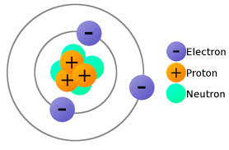In the space below draw an atom of Oxygen, showing all the protons, neutrons and electrons. The diagram of lithium is shown as an . In your diagram label the protons, neutrons, electrons, and nucleus.

Example – Lithium atom (unlabelled)

1. Fill in this table:

|  |  |  |  |  |  |  |  |
| --- | --- | --- | --- | --- | --- | --- | --- |
| ELEMENT | SYMBOL | ATOMIC NUMBER | ATOMIC MASS | Number of PROTONS | Number of NEUTRONS | Number of ELECTRONS | ION FORMED |
| Magnesium |  | 12 |  |  | 12 |  |  |
|  | Na |  | 23 | 11 |  |  |  |
| Oxygen |  |  |  |  | 8 | 8 |  |
|  |  |  | 27 | 13 |  |  | Al +3 |

1. Draw crosses on the circles below to show the electron arrangements of Magnesium and Carbon below. Write the number of neutrons and protons in the nucleus and the configuration on the line below.

Electron Arrangement: ___________________ Electron Arrangement: ____________________

1. Write down the name of the elements and how many there are in each of these compounds:

Example: H2O = 2 x hydrogen; 1 x oxygen

1. Calcium Chloride Ca Cl2 = _______________________________________________________
2. Aluminium Sulphate Al2 (SO4)3 = _____________________________________________________
3. 3 molecules of Lithium Carbonate 3 Li2 CO3 __________________________________________________________________________________
4. Given the following reaction:

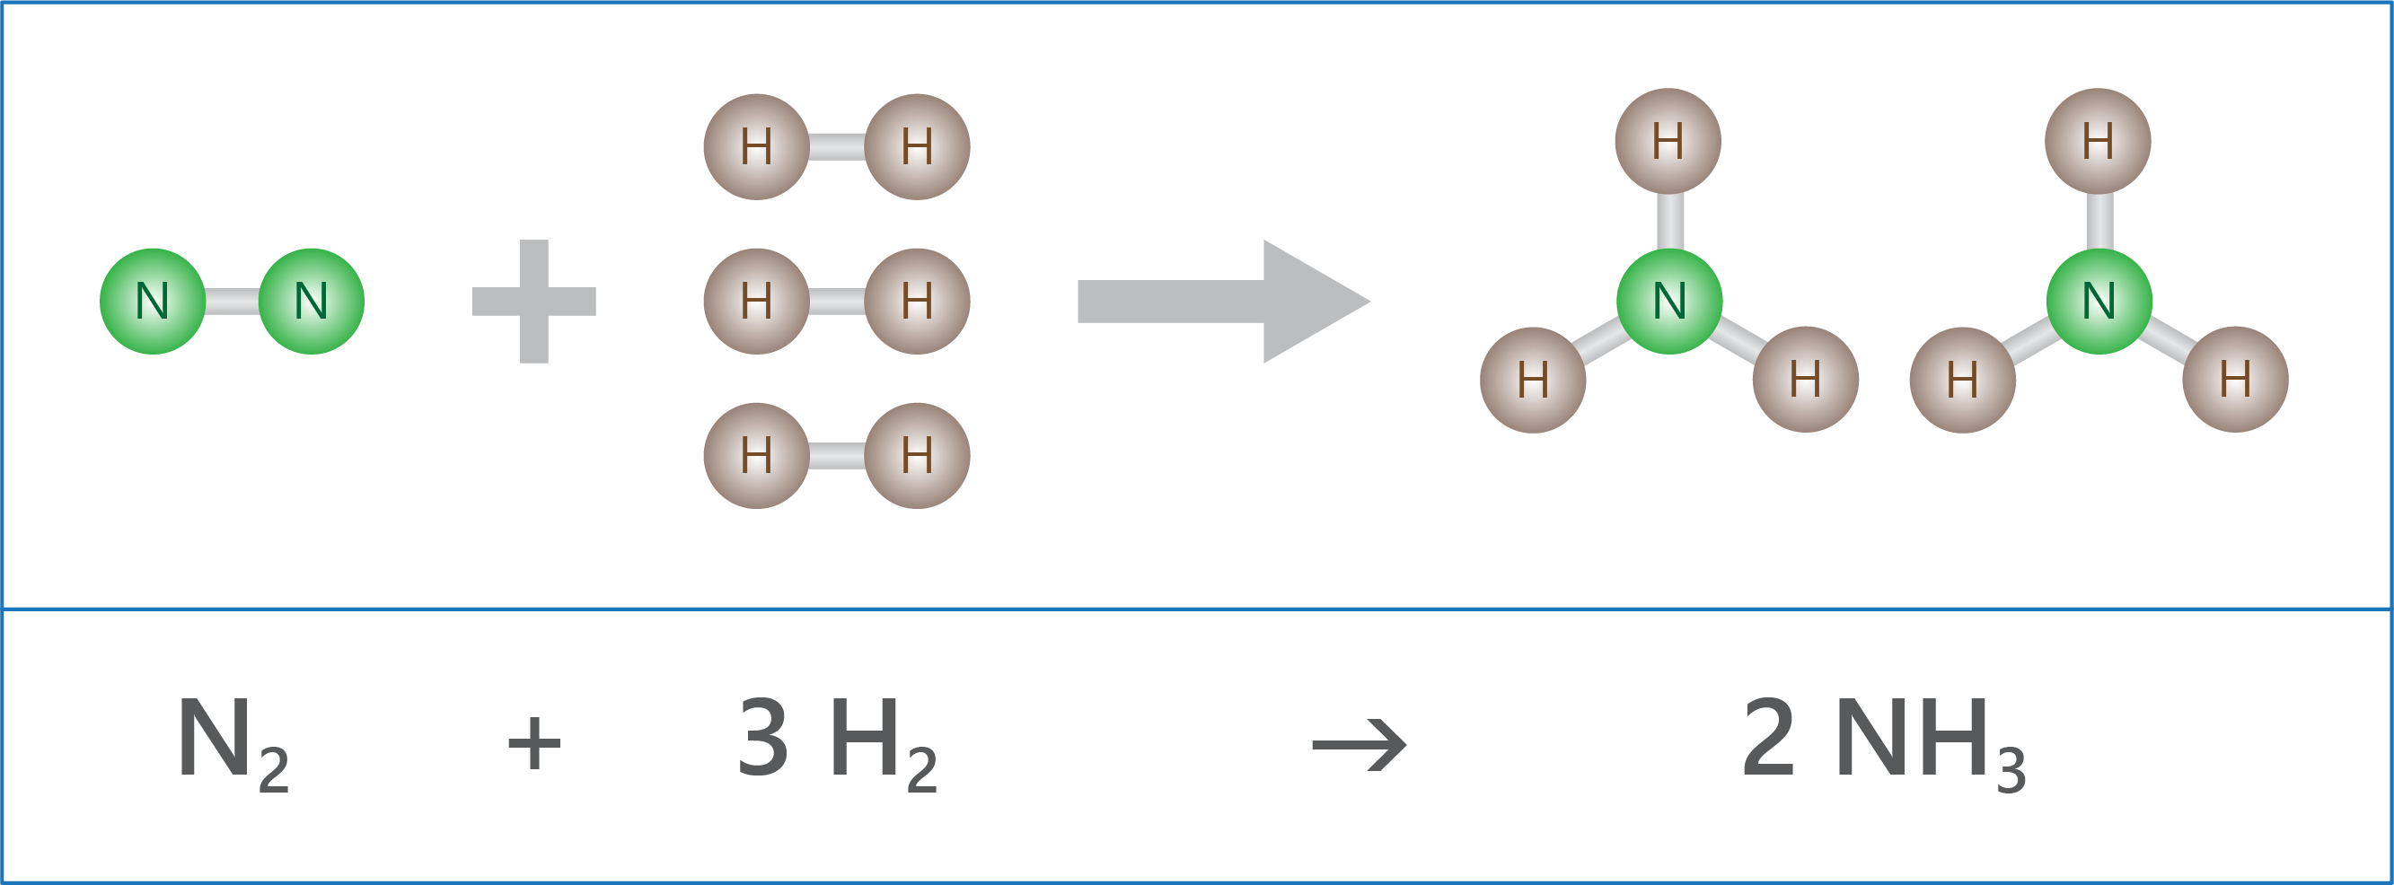**Reaction A**

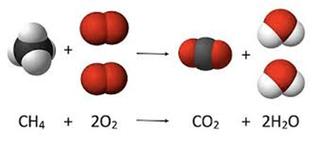**Reaction B**

1. For each reaction list the reactants and the products:

_____________________________________________________________________________________

_____________________________________________________________________________________

1. For each of the reaction list the bonds that are broken in the reactants and the new bonds which are formed to make the products.

_____________________________________________________________________________________

_____________________________________________________________________________________

_____________________________________________________________________________________

1. For each of the following chemical reaction indicate if the reaction is exothermic or endothermic.
2. C6H12O6 + 6O2 → 6CO2 + 6H2O + energy ____________
3. HC2H3O2 + NaHCO3 + energy → NaC2H3O2 + H2O + CO2 ____________
4. lime + carbon dioxide ---> calcium carbonate (temp increases) ____________
5. ammonium nitrate ---> water and dinitrogen oxide (temp decreases) ____________
6. Explain how a combustion reaction is similar to an oxidation reaction. Explain how the two types of reactions are different to each other.

_____________________________________________________________________________________

_____________________________________________________________________________________

_____________________________________________________________________________________

1. Explain the role that Photosynthesis and Respiration reactions play in your life.

_____________________________________________________________________________________

_____________________________________________________________________________________

_____________________________________________________________________________________

1. **The consequences of increased CO2 in our air include acidification of seawater and a decrease in carbonate ion (CO32-) concentration. The early life stages of invertebrates, such as squid, may be particularly vulnerable to changes in carbon dioxide levels**

**In order to determine how increased levels of carbon dioxide affect the development of squid, eggs were hatched in two different conditions: normal (380 µatm) and elevated (2100 µatm) levels of CO2. The time to hatch and the size of the larvae were measured and recorded. Two trials were conducted for each carbon dioxide concentration.**

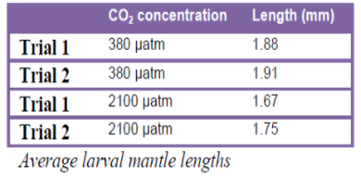

Table showing larval length

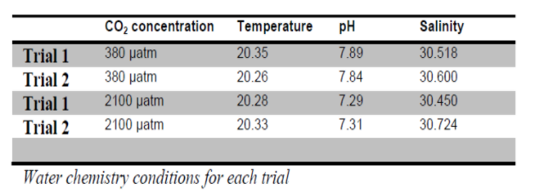

General table

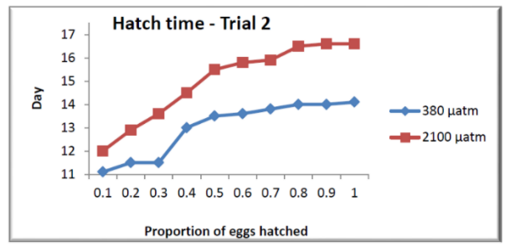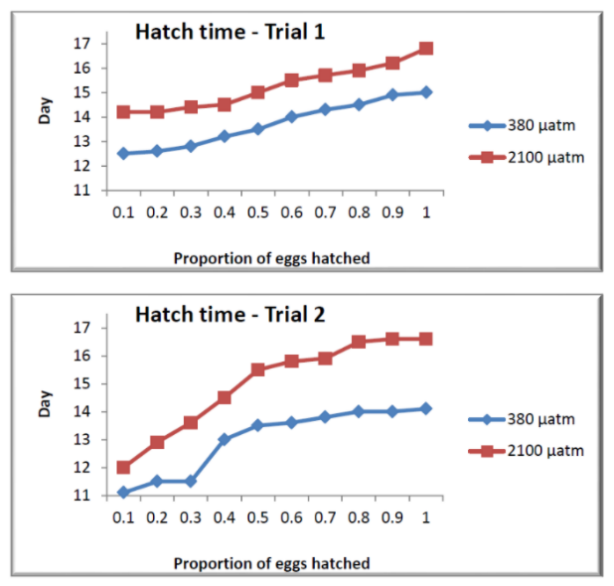

Graphs showing hatching time

Does the data in the tables and graphs above show that increased CO2 in the ocean affects the development of squid eggs? Using the data, explain your reasoning.

_____________________________________________________________________________________

_____________________________________________________________________________________

_____________________________________________________________________________________

_____________________________________________________________________________________

_____________________________________________________________________________________